Microorganisms are everywhere but some places more than others. Just because microorganisms are on an object doesn’t make them dirt or gross or toxic or bad. Most of the microorganisms that exists in our world are not harmful not humans, we call this non-pathogenic.

You should have LB agar plates from the making agar plates exercise. If you don’t have plates go follow that guide and make some now!

For this experiment we are going to culture some bacteria and maybe some yeasts and fungus. In order to do that you need to take the plates you made and touch them with what you want to test. For instance, if you want to test and see the bacteria growing on your hand you can touch your fingers to one plate, touch your hand with a nitrile glove on to another plate and your hand immediately after you wash it with soap and water to another.

Using a q-tip or cotton swab you can swab meat you plan to eat.

Using your pipette you can even take a few drops of tap water and see how that fairs.

This is going to be fun because you get to choose what you want to culture.

One thing to remember is that you are going to need a control. In science a control is a part of an experiment that is added to help make sure you experiment doesn’t have things happen that you weren’t prepared for.

For example, in this experiment you might want to take a plate and let it incubate on the counter with the rest untouched and never opened to make sure bacteria didn’t get all over your plate before you even started the experiment! If something grows on your “control” plate you know that the other ones might be contaminated as well because nothing was done to this control plate. Another example, if you want to test tap water, you might also want to test bottled water or distilled water as a control.

1. The first thing to do is take your plates out of the fridge and let them warm to room temperature. This can take 30 minutes or so.
2. Make sure you are wearing gloves and clean your gloves and work area with alcohol if you have it.
3. Make a list of all the different experiments you want to do and make sure you have some controls and enough plates.
4. Label each of your plates using a sharpie or marker. If you don’t have a sharpie or marker you can always tape a piece of paper that has a label to the plate.
5. If you want you can even divide each plate into two halves and use one half for each experiment.

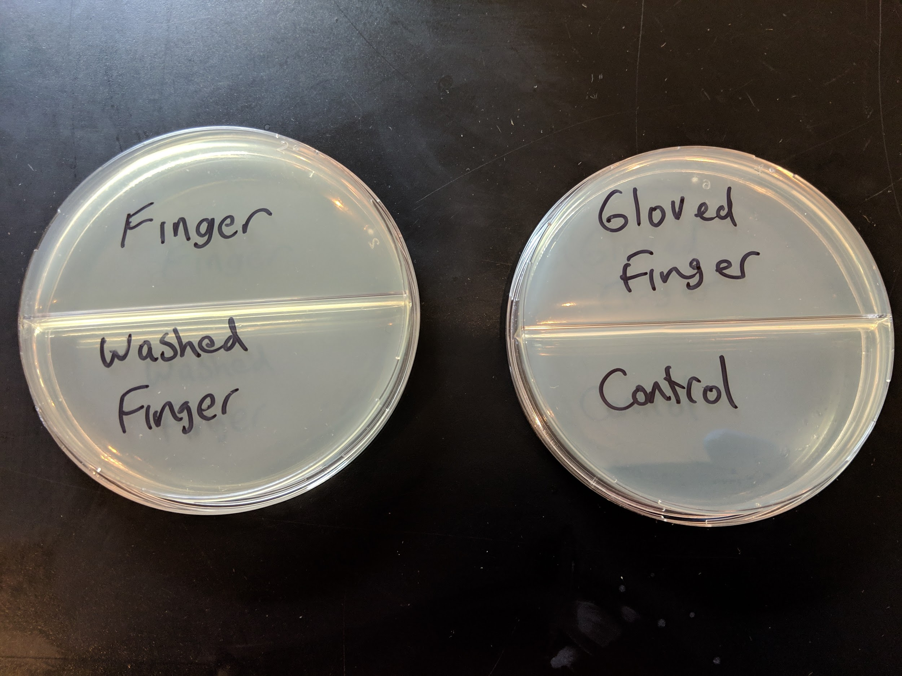

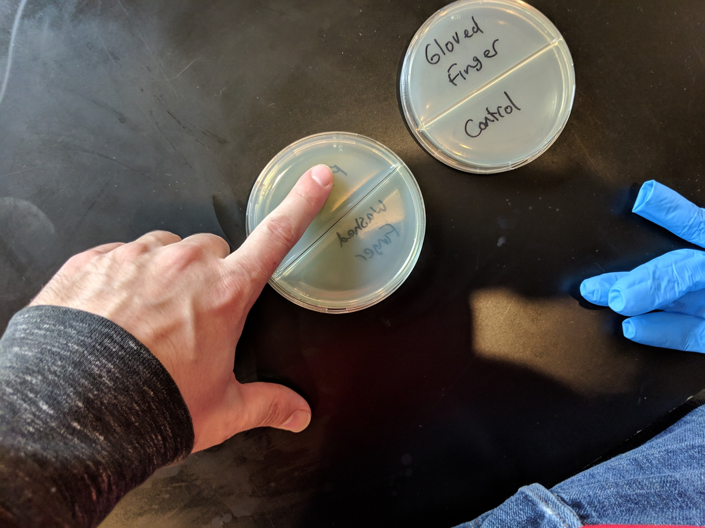

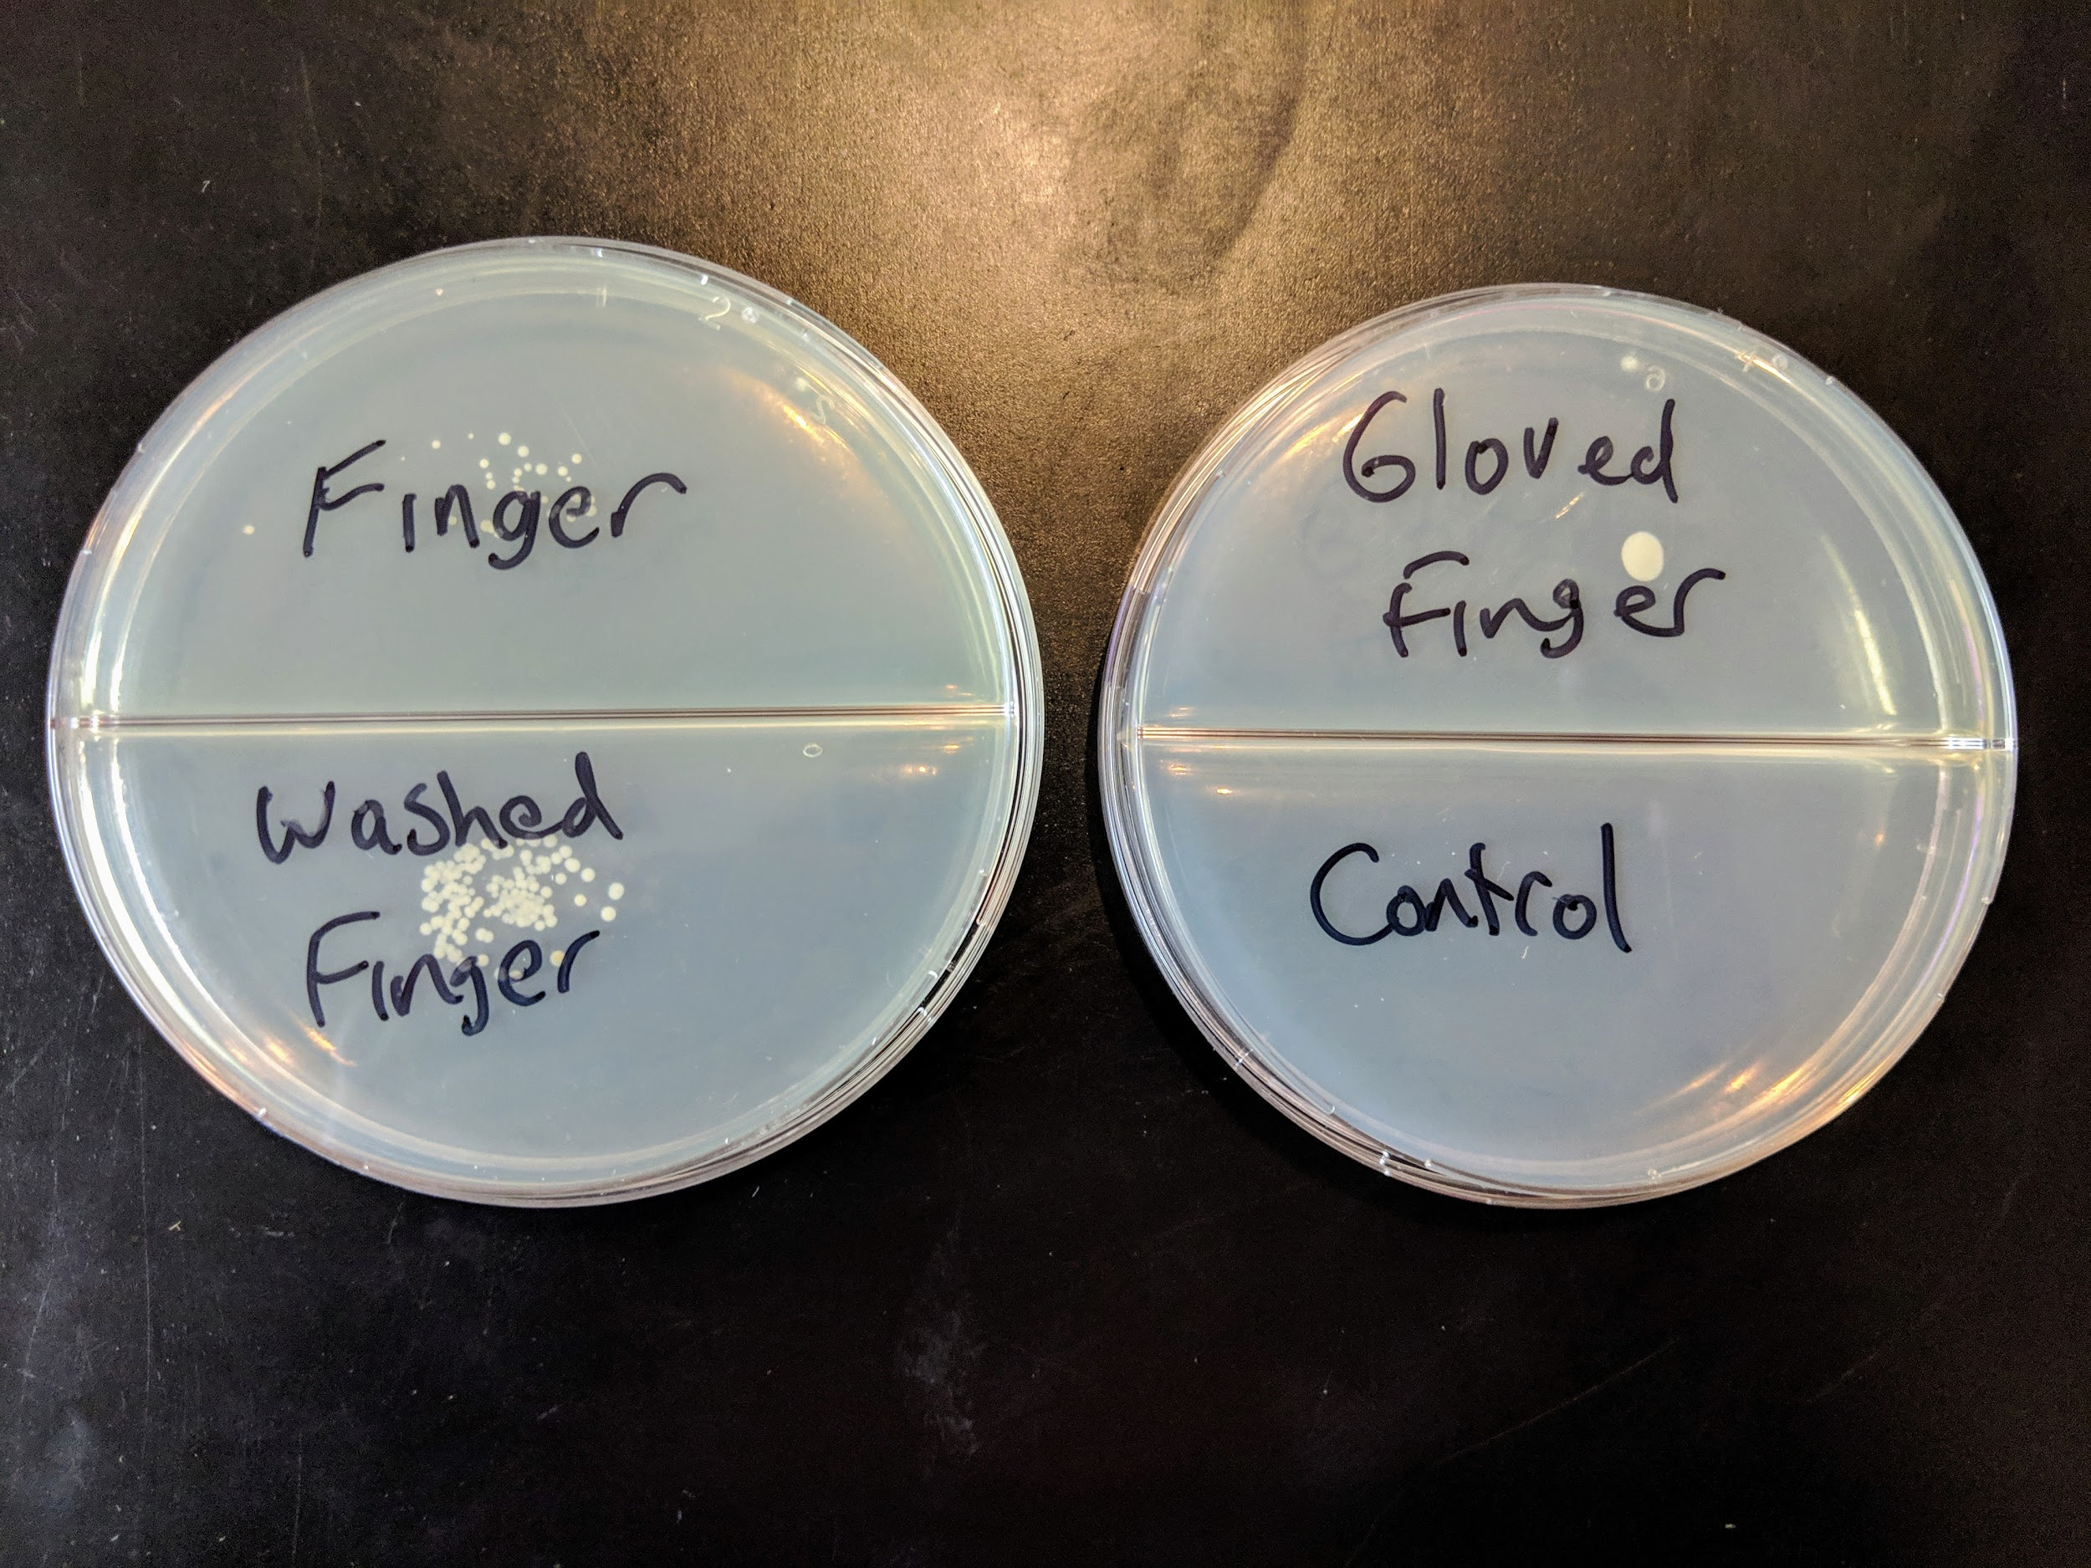

For some reason my washed finger had more bacteria on it than before the washing. Probably because my washed finger was still a little wet and so more bacteria was easily transferred. There was the least bacteria on my gloved finger and also it was a different type. You can see that because it is one big “colony”(a colony is what scientists call a circle of bacteria, it is how they grow usually) instead of smaller ones.

Feel free to repeat this experiment or do one of your own and share pictures on the Facebook group.